Experiment no-12
Insure Easy – Insurance Management System
AIM:
To develop an online insurance management website using HTML, CSS, and JavaScript to manage insurance policies and customer details. The system allows users to view policy information and check premium payment reminders.
PROCEDURE:
- Create an HTML page for entering customer and policy details.
- Apply CSS to design the page.
- Use JavaScript to validate the details.
- Display the insurance policy information.
- Run the program in a web browser.

Sample Code:

<!DOCTYPE html>
<html>
<body>
<h2>Insurance Management</h2>
<input id="name" placeholder="Customer Name">
<select id="policy">
<option>Health Insurance</option>
<option>Vehicle Insurance</option>
<option>Home Insurance</option>
</select>
<button onclick="showPolicy()">View Policy</button>
<p id="result"></p>

<script>
function showPolicy() {
let name = document.getElementById("name").value;
let policy = document.getElementById("policy").value;

if (name) {
document.getElementById("result").innerHTML =
"Customer: " + name + "<br>Policy: " + policy;
} else {
document.getElementById("result").innerHTML =
"Please enter customer name.";
}
}
</script>
</body>
</html>
Sample Output:
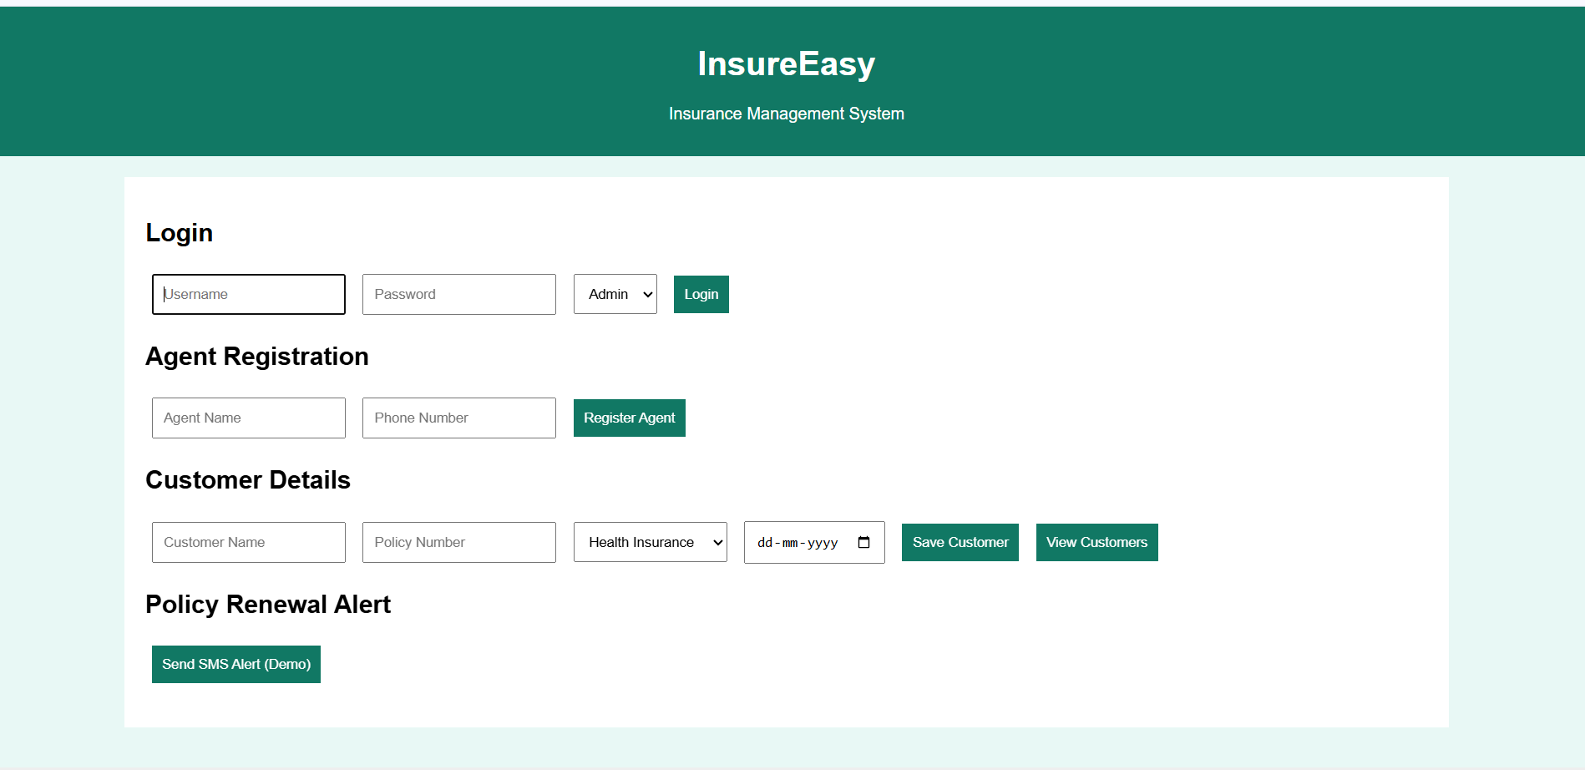
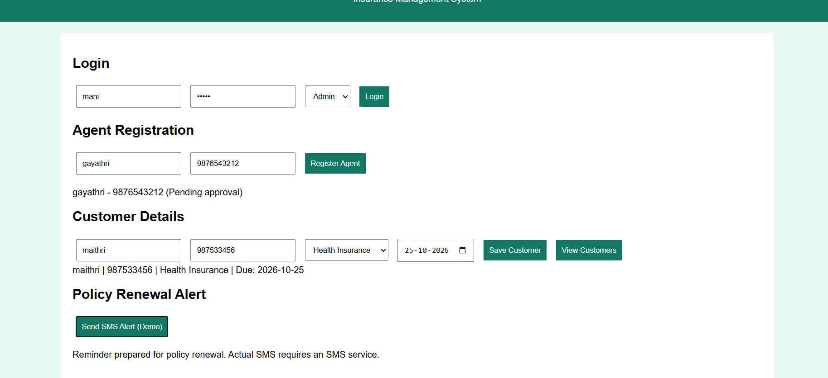

Result:
Thus, the InsureEasy website was developed successfully to enter customer details and display insurance policy information.

